Assignment for Module 10
The assignment for Module 10 involves problems for schema conversion.
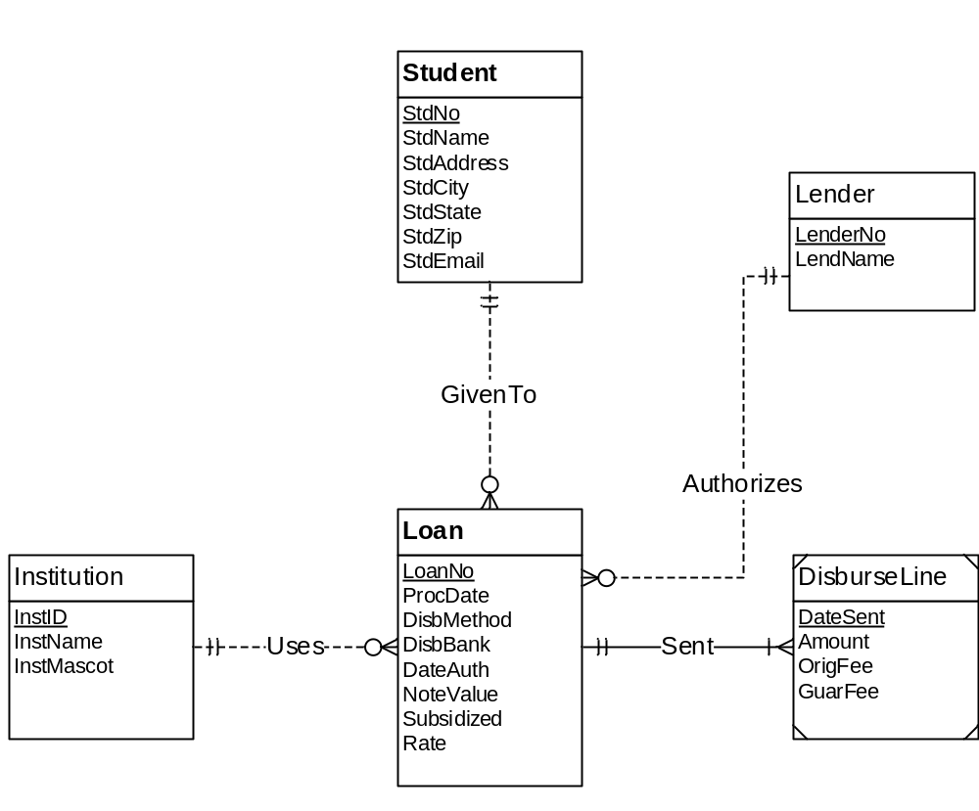
Figure 1: ERD for Problems 1 to 4
1. Requirements for Data Modeling Problems
- For the ERD in Figure 1, you should indicate the applications of the entity type rule. For each entity type rule application, you should identify the table name, primary key, and other columns. You do not need to write CREATE TABLE statements.
Institution(InstID , InstName, InstMascot)
Student(StdId, StdName,StdAddr, StdCity, StdState, StdZip, StdEmail)
Lender(LenderNo, LenderName)
DisburseLine(DateSent, Amount, OrigFee,GuarFee)
Loan(LoanNo, ProcDate, DisbMethod, DisbBank, DateAuth, NoteValue, Subsidized, Rate)

- For the ERD in Figure 1, you should indicate applications of the 1-M relationship rule. For each 1-M relationship rule application, you should indicate the changes to the tables you listed in problem 1 including foreign key columns and NOT NULL constraints for foreign keys if necessary.
Loan( LoanNo, InstID, StdId, LenderId, ProcDate, DisbMethod, DisbBank, DateAuth, NoteValue, Subsidized, Rate
Foreign Key(InstID) references Institute,
Foreign Key(StdId) references Student,
Foreign Key(LenderId) references Lender
InstId,StdId,LenderId NOT NULL )
DisburseLine(DateSent, Loan Amount, OrigFee,GuarFee
Foreign Key(LoanNo) references Loan)

- For the ERD in Figure 1, you should indicate applications of the M-N relationship rule. For each M-N relationship rule application, you should list the table name, primary key, and other columns.
- For the ERD in Figure 1, you should indicate applications of the identifying relationship rule. For each identifying relationship rule application, you should indicate the changes to the tables you listed in problem 2.
DisburseLine(DateSent, Loan Amount, OrigFee,GuarFee
Foreign Key(LoanNo) references Loan)

5. Convert the ERD shown in Figure 2 into tables. List the conversion rules used and table design. For each table, you should list the primary key, foreign keys, other columns, and NOT NULL constraints for foreign keys if necessary. You do not need to write CREATE TABLE statements.
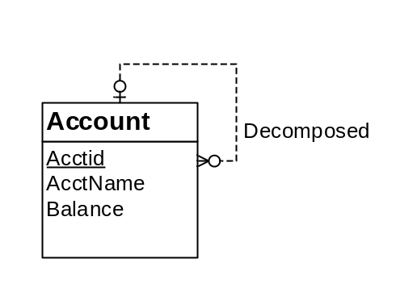
Figure 2: ERD for Conversion Problem 5

Conversion Rule : 1-M Relation Conversion Rule.
Account ( AcctID, decomposedAccId, AcctNAme, Balance
Foreign Key(decomposedAccId) References Account
decomposedAccId NOT NULL)

6. Convert the ERD shown in Figure 3 into tables. List the conversion rules used and table design. For each table, you should list the primary key, foreign keys, other columns, and NOT NULL constraints for foreign keys if necessary. You do not need to write CREATE TABLE statements.
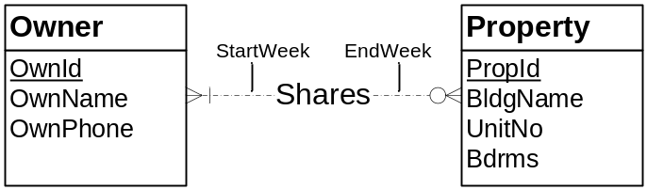
Figure 3: ERD for Conversion Problem 6
Solution :
Owner(OwnId,OwnName,OwnPhone)
Property(PropId,BidgName,UnitNo,Bdrms)
Shares(OwnId,PropID,StartWeek,EndWeek,
FOREIGN KEY(OwnId) REFERENCES Owner,
FOREIGN KEY(PropID) REFERENCES Property,
OwnId NOT NULL)
Rules of conversion.
Entity type rule to convert each entity type
1-M relationship rule for all relationships except the shares relationship
M-N Relation Rule.

